**DATAWEAVE TASK-3**

**Filtering data:**

**QUESTION:**

Consider the following input payload with an array of 4 objects. As each object has lineTypeCode - HOME and AUTO.   
We would like to get the latest record of each lineTypeCode based on the serviceSummaries.serviceSummaryItem.effectiveDate  
**Note:** Each object has 2 serviceSummaryItem, we would like to get only the latest one.  
  
For example - consider the following payload:

[  
 {a:"home", b: [{t: 1}, {t:2} ], c: 1},   
 {a:"home", b: [{t: 1}, {t:4} ], c: 2},   
 {a:"auto", b: [{t: 1}, {t:2} ], c: 3}  
]

it should return the following -

[ {a:"home", b: [{t: 4}], c: 2}, {a:"auto", b: [{t:2}]}]

Please note that the data is combined based on the key a which share the same value and highest value of t is returned from the key b along with the rest of the payload.  
  
**Input Payload:**  
https://openlogix.slack.com/files/U871FTK0F/F06412F1V41/response.json  
**Expected Output:**

[  
 {  
 "agencyCommissionAmount": "",  
 "agencyCommissionPercent": 0,  
 "agencyCommissionType": "%",  
 "agencyDefinedCategoryItems": "",  
 "agreementID": -1,  
 "annualizedCommission": 0,  
 "annualizedPremium": 684,  
 "billedCommission": 0,  
 "billedPremium": 684,  
 "billingModeOption": {  
 "optionName": "DirectBilled",  
 "value": 1  
 },  
 "billingValue": {  
 "billBrokerNet": false,  
 "billingPlan": "Annually",  
 "financedFlag": false,  
 "invoiceToAccountLookupCode": "LOZINARO01",  
 "invoiceToAddress": {  
 "city": "Lewiston",  
 "countryCode": "USA",  
 "county": "",  
 "stateOrProvinceCode": "NY",  
 "street1": "788 Thornwood Drive",  
 "street2": "",  
 "street3": "",  
 "zipOrPostalCode": 14092  
 },  
 "invoiceToAddressDescription": "",  
 "invoiceToContactID": 114892,  
 "invoiceToContactName": "Robert J Lozina",  
 "invoiceToDeliveryMethod": "Mail",  
 "invoiceToEmail": "",  
 "invoiceToFaxCountryCode": "",  
 "invoiceToFaxExtension": "",  
 "invoiceToFaxNumber": "",  
 "invoiceToSiteID": "",  
 "invoiceToType": "Client",  
 "loanNumber": "",  
 "taxOptionCode": ""  
 },  
 "defaultCommissionAgreement": false,  
 "downloaded": 684,  
 "estimatedCommission": 0,  
 "estimatedMonthlyCommission": "",  
 "estimatedMonthlyPremium": "",  
 "estimatedMonthlyPremiumAsOfDate": "",  
 "estimatedPremium": 684,  
 "historyValue": {  
 "comments": "",  
 "dateFirstWritten": "2010-07-09T00:00:00",  
 "brokerOfRecordDate": ""  
 },  
 "issuingCompanyLookupCode": "WESINS",  
 "issuingLocationCode": "NY",  
 "lineGUID": "4EA86118-1FAC-4617-9A82-41573A586021",  
 "lineID": 393874,  
 "lineInformationLineID": "",  
 "lineTypeCode": "HOME",  
 "lineTypeDescription": "Homeowners",  
 "payableContractID": "",  
 "policyID": 392480,  
 "premiumPayableLookupCode": "CIGINS",  
 "premiumPayableTypeCode": "CA",  
 "producerBrokerCommissionsValue": {  
 "commissions": {  
 "commissionItem": {  
 "commissionAmount": "",  
 "commissionID": 379587,  
 "commissionPercent": 0,  
 "commissionType": "@",  
 "flag": "View",  
 "lookupCode": "AAAHOU",  
 "orderNumber": 0,  
 "producerBrokerCode": "PPAY",  
 "productionCredit": 100,  
 "commissionAgreementID": 0,  
 "contractID": "",  
 "contractName": "",  
 "shareRevenueAgencyCode": "",  
 "shareRevenueAgencyID": -1,  
 "shareRevenueAgencyName": "",  
 "shareRevenueBranchCode": "",  
 "shareRevenueBranchID": -1,  
 "shareRevenueBranchName": "",  
 "shareRevenueDepartmentCode": "",  
 "shareRevenueDepartmentID": -1,  
 "shareRevenueDepartmentName": "",  
 "shareRevenuePercent": 0,  
 "shareRevenueProfitCenterCode": "",  
 "shareRevenueProfitCenterID": -1,  
 "shareRevenueProfitCenterName": "",  
 "prBrLineCommissionAnnualized": 0,  
 "prBrLineCommissionEstimated": "",  
 "overrideCommissionAgreementPercentageOrAmount": false,  
 "useCommissionAgreement": false  
 }  
 },  
 "producerBrokerCommissionTermOption": {  
 "optionName": "SingleTermCommission",  
 "value": 0  
 },  
 "producerBrokerScheduleTermItems": ""  
 },  
 "profitCenterCode": "DEF",  
 "risksInsured": "",  
 "risksInsuredDescription": "",  
 "serviceSummaries": {  
 "serviceSummaryItem": [  
 {  
 "action": "Endorse/Revise",  
 "description": "Company Download",  
 "effectiveDate": "2024-12-13T00:00:00",  
 "enteredDate": "2021-12-15T11:04:04.827",  
 "serviceSummaryID": 576942,  
 "serviceSummaryVersion": 2,  
 "stage": "Issued",  
 "stageChangedDate": ""  
 }  
 ]  
 },  
 "servicingContacts": {  
 "servicingRoleItem": [  
 {  
 "description": "",  
 "employeeLookupCode": "AAAHOU",  
 "role": "Producer",  
 "code": "PRO"  
 },  
 {  
 "description": "",  
 "employeeLookupCode": "AAACSR",  
 "role": "Client Service Rep",  
 "code": "CSR"  
 }  
 ]  
 },  
 "statusCode": "REN",  
 "timestamp": "2021-12-15T11:04:04.82",  
 "totalEligible": "",  
 "totalEligibleDescription": "",  
 "ignoreAtLeastOnePrBrCommissionRequirement": false,  
 "overrideCommissionAgreementPercentageOrAmount": false,  
 "planOptionName": "",  
 "ignoreLineStatusCodeOnUpdate": false,  
 "policyDetailEngineID": ""  
 },  
 {  
 "agencyCommissionAmount": "",  
 "agencyCommissionPercent": 0,  
 "agencyCommissionType": "%",  
 "agencyDefinedCategoryItems": "",  
 "agreementID": -1,  
 "annualizedCommission": "",  
 "annualizedPremium": "",  
 "billedCommission": "",  
 "billedPremium": "",  
 "billingModeOption": {  
 "optionName": "DirectBilled",  
 "value": 1  
 },  
 "billingValue": {  
 "billBrokerNet": false,  
 "billingPlan": "Annually",  
 "financedFlag": false,  
 "invoiceToAccountLookupCode": "LOZINARO01",  
 "invoiceToAddress": {  
 "city": "Lewiston",  
 "countryCode": "USA",  
 "county": "",  
 "stateOrProvinceCode": "NY",  
 "street1": "788 Thornwood Drive",  
 "street2": "",  
 "street3": "",  
 "zipOrPostalCode": 14092  
 },  
 "invoiceToAddressDescription": "",  
 "invoiceToContactID": 114892,  
 "invoiceToContactName": "Robert J Lozina",  
 "invoiceToDeliveryMethod": "Mail",  
 "invoiceToEmail": "",  
 "invoiceToFaxCountryCode": "",  
 "invoiceToFaxExtension": "",  
 "invoiceToFaxNumber": "",  
 "invoiceToSiteID": "",  
 "invoiceToType": "Client",  
 "loanNumber": "",  
 "taxOptionCode": ""  
 },  
 "defaultCommissionAgreement": false,  
 "downloaded": "",  
 "estimatedCommission": "",  
 "estimatedMonthlyCommission": "",  
 "estimatedMonthlyPremium": "",  
 "estimatedMonthlyPremiumAsOfDate": "",  
 "estimatedPremium": "",  
 "historyValue": {  
 "comments": "",  
 "dateFirstWritten": "2013-07-06T00:00:00",  
 "brokerOfRecordDate": ""  
 },  
 "issuingCompanyLookupCode": "WESINS",  
 "issuingLocationCode": "NY",  
 "lineGUID": "86E38EBE-4E10-4547-9B1E-2308AD9918BB",  
 "lineID": 393876,  
 "lineInformationLineID": "",  
 "lineTypeCode": "AUTO",  
 "lineTypeDescription": "Personal Automobile",  
 "payableContractID": "",  
 "policyID": 392480,  
 "premiumPayableLookupCode": "CIGINS",  
 "premiumPayableTypeCode": "CA",  
 "producerBrokerCommissionsValue": {  
 "commissions": {  
 "commissionItem": {  
 "commissionAmount": "",  
 "commissionID": 379588,  
 "commissionPercent": 0,  
 "commissionType": "@",  
 "flag": "View",  
 "lookupCode": "AAAHOU",  
 "orderNumber": 0,  
 "producerBrokerCode": "PPAY",  
 "productionCredit": 100,  
 "commissionAgreementID": 0,  
 "contractID": "",  
 "contractName": "",  
 "shareRevenueAgencyCode": "",  
 "shareRevenueAgencyID": -1,  
 "shareRevenueAgencyName": "",  
 "shareRevenueBranchCode": "",  
 "shareRevenueBranchID": -1,  
 "shareRevenueBranchName": "",  
 "shareRevenueDepartmentCode": "",  
 "shareRevenueDepartmentID": -1,  
 "shareRevenueDepartmentName": "",  
 "shareRevenuePercent": 0,  
 "shareRevenueProfitCenterCode": "",  
 "shareRevenueProfitCenterID": -1,  
 "shareRevenueProfitCenterName": "",  
 "prBrLineCommissionAnnualized": "",  
 "prBrLineCommissionEstimated": "",  
 "overrideCommissionAgreementPercentageOrAmount": false,  
 "useCommissionAgreement": false  
 }  
 },  
 "producerBrokerCommissionTermOption": {  
 "optionName": "SingleTermCommission",  
 "value": 0  
 },  
 "producerBrokerScheduleTermItems": ""  
 },  
 "profitCenterCode": "DEF",  
 "risksInsured": "",  
 "risksInsuredDescription": "",  
 "serviceSummaries": {  
 "serviceSummaryItem": [  
 {  
 "action": "Renew",  
 "description": "Renewal",  
 "effectiveDate": "2022-07-06T00:00:00",  
 "enteredDate": "2021-06-28T13:06:00.747",  
 "serviceSummaryID": 503165,  
 "serviceSummaryVersion": 1,  
 "stage": "Issued",  
 "stageChangedDate": ""  
 }  
 ]  
 },  
 "servicingContacts": {  
 "servicingRoleItem": [  
 {  
 "description": "",  
 "employeeLookupCode": "AAAHOU",  
 "role": "Producer",  
 "code": "PRO"  
 },  
 {  
 "description": "",  
 "employeeLookupCode": "AAACSR",  
 "role": "Client Service Rep",  
 "code": "CSR"  
 }  
 ]  
 },  
 "statusCode": "REN",  
 "timestamp": "2021-12-15T11:04:04.913",  
 "totalEligible": "",  
 "totalEligibleDescription": "",  
 "ignoreAtLeastOnePrBrCommissionRequirement": false,  
 "overrideCommissionAgreementPercentageOrAmount": false,  
 "planOptionName": "",  
 "ignoreLineStatusCodeOnUpdate": false,  
 "policyDetailEngineID": ""  
 }  
]

**SOLUTION:**

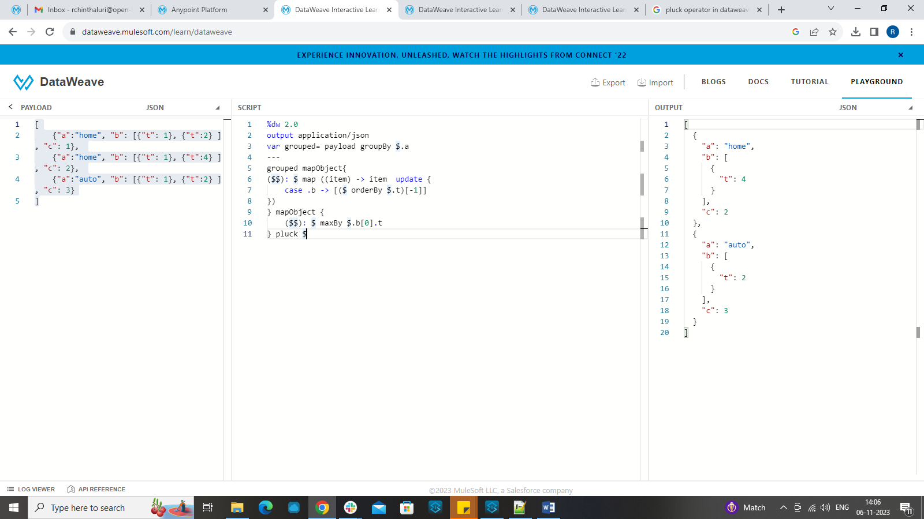

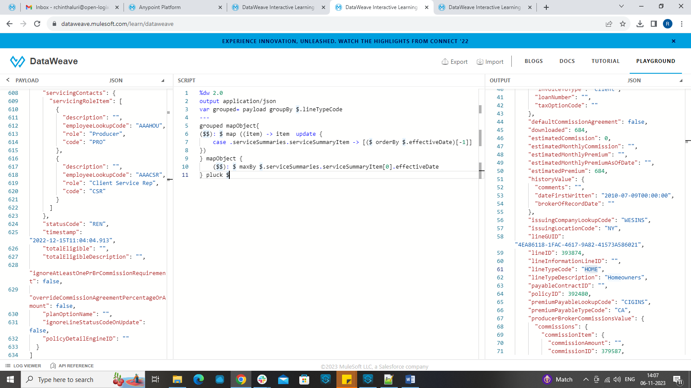

The task given here is about filtering of data by using a payload consisting of array of four objects. Since it has lot many details in the original payload than expected, let us make the concept simple. First Let’s simplify the payload into a format which we will understand and later on we can use the actual payload.

Consider the example payload below.

Here the filtering is done based on the key “a” which contains two values "home" or "auto".

Here we need to return highest value of t from the key b along with the other payload.

So first, we need to group the items based on the key 'a'.

For that we can use groupBy function and consider the grouped payload as a variable and perform the actual operation on it.

Variable with name grouped is declared in the header section of dataweave.

after that, since the payload after grouping is an object, we can use mapObject here.

mapObject works through each element of an object in the presented order and puts the output into an object.

we can use the simple syntaxes of $ (value), $$ (key), and $$$ (index) for doing transformation.

For doing the further transformation, we used update function.

update function updates a field in an object with the specified string value. The function returns a new object with the specified field and value.

We can update the payload based on certain condition where we update by taking the t values from the payload.

when the payload obtained again is an object, we use mapObject and maxBy to get the highest one from the available values.

Finally, to transform the output from an object to array we use pluck function.

SAMPLE PAYLOAD:

[

{"a":"home", "b": [{"t": 1}, {"t":2} ], "c": 1},

{"a":"home", "b": [{"t": 1}, {"t":4} ], "c": 2},

{"a":"auto", "b": [{"t": 1}, {"t":2} ], "c": 3}

]

-------------------

%dw 2.0

output application/json

var grouped= payload groupBy $.lineTypeCode

---

grouped mapObject{

($$): $ map ((item) -> item update {

case .b -> [($ orderBy $.t)[-1]]

})

} mapObject {

($$): $ maxBy $.b[0].t

} pluck $

Original payload: attached in the question above.

Solution:

%dw 2.0

output application/json

var grouped= payload groupBy $.lineTypeCode

---

grouped mapObject{

($$): $ map ((item) -> item update {

case .serviceSummaries.serviceSummaryItem -> [($ orderBy $.effectiveDate)[-1]]

})

} mapObject {

($$): $ maxBy $.serviceSummaries.serviceSummaryItem[0].effectiveDate

} pluck $